**TUGAS 05**

**PRAK06 Quizzler**



Praktikum Pemrograman Berbasis Web - A

Nama :

Adelia Nurlina Putri 4521210059

**PROGRAM STUDI S1 TEKNIK INFORMATIKA**

**FAKULTAS TEKNIK**

**UNIVERSITAS PANCASILA**

**JAKARTA**

**2024**

1. **Project quizzler**
   1. **First Initialization**
2. Akses web <https://docs.flutter.dev/ui/layout/tutorial>
3. Buka Android Studio

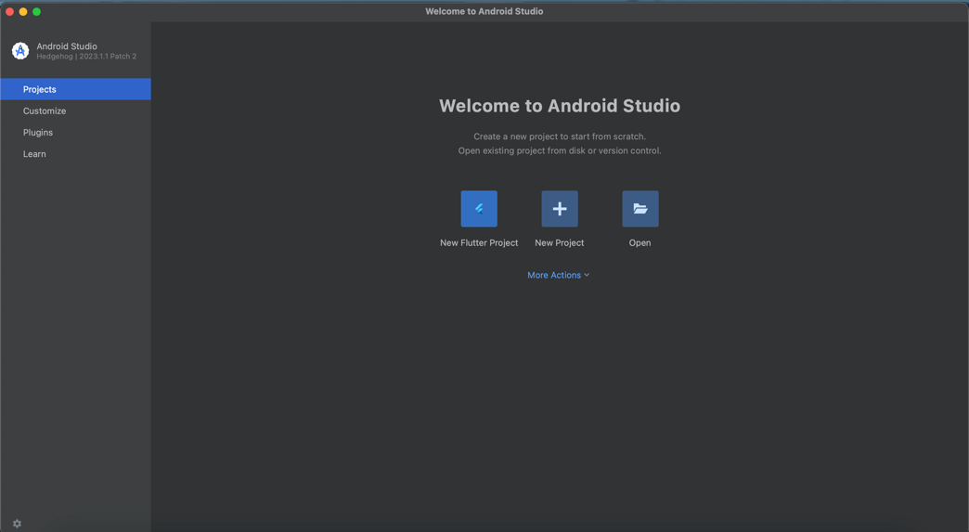

1. Pilih New Flutter Project -> Flutter -> Next

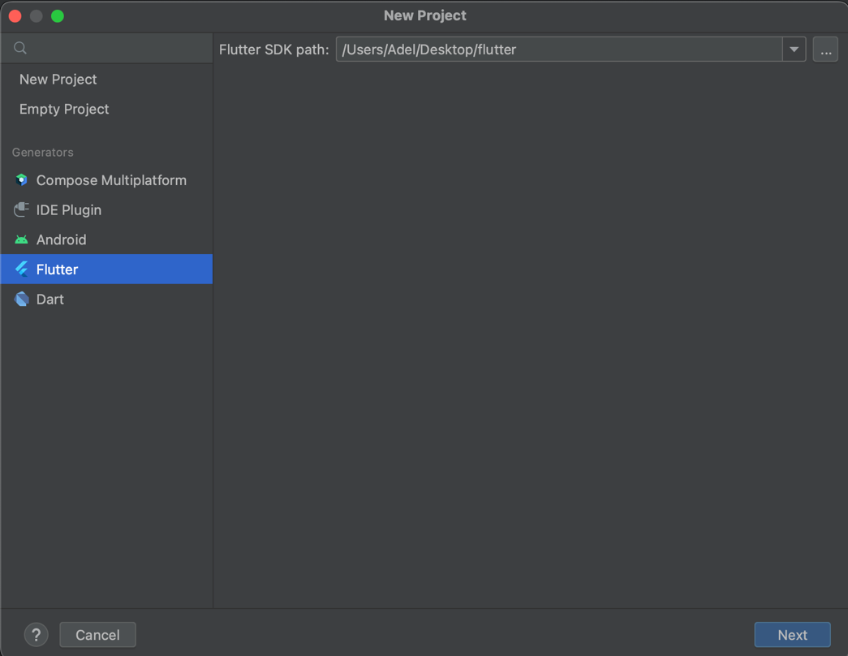

1. Isi form untuk nama project, tempat project, type, bahasa pemrograman, platforms dan lainnya -> Create

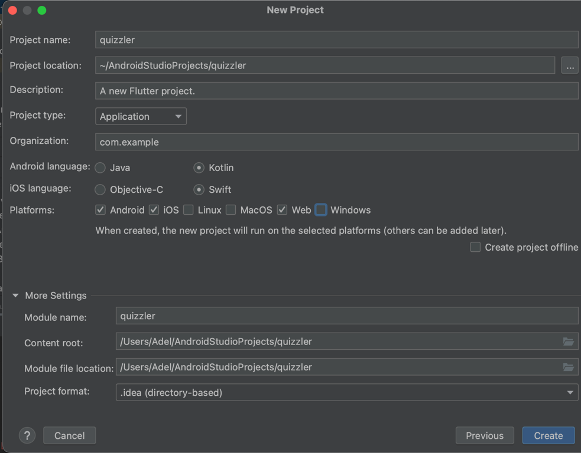

* 1. **Membuat Layout**

1. File main.dart

|  |
| --- |
| import 'package:flutter/material.dart'; import 'package:quizzler/quiz_brain.dart'; import 'package:rflutter_alert/rflutter_alert.dart';  // membuat object QuizBrain quizBrain = QuizBrain();  // fungsi main void main() {  runApp(const QuizzlerApp()); }  class QuizzlerApp extends StatelessWidget {  const QuizzlerApp({super.key});   @override  Widget build(BuildContext context) {  return MaterialApp(  home: Scaffold(  backgroundColor: Colors.*white*,  appBar: AppBar(  title: const Text(  'NCT 127 QUIZZES',  style: TextStyle(  color: Colors.*black*,  fontWeight: FontWeight.*bold*,  ),  ),  backgroundColor: Colors.*lightGreenAccent*,  ),  body: const SafeArea(  child: Padding(  padding: EdgeInsets.symmetric(horizontal: 10.0),  child: QuizPage(),  ),  ),  ),  );  } }  class QuizPage extends StatefulWidget {  const QuizPage({super.key});   @override  State<QuizPage> createState() => _QuizPageState(); }  class _QuizPageState extends State<QuizPage> {  List<Icon> scoreKeeper = [];   // menghitung jawaban benar dan salah  int numCorrect = 0;  int numIncorrect = 0;   void checkAnswer(bool userPickedAnswer) {  bool correctAnswer = quizBrain.getCorrectAnswer();   // setState  setState(() {  // mengecek quiz telah selesai atau belum  if (quizBrain.isFinished()) {  // jika quiz sudah selesai  Alert(  context: context,  title: 'Finished',  desc: 'You\'ve reached the end of the Quiz\n'  'Correct Answers: $numCorrect\n'  'Incorrect Answers: $numIncorrect\n'  'Total Questions: ${quizBrain.getTotalQuestions()}',  ).show();   quizBrain.reset();  scoreKeeper = [];   } else {  if (userPickedAnswer == correctAnswer) {  scoreKeeper.add(const Icon(  Icons.*check_circle*,  color: Colors.*lightGreenAccent*,  ));  numCorrect++;  } else {  scoreKeeper.add(const Icon(  Icons.*close_sharp*,  color: Colors.*red*,  ));  numIncorrect++;  }  quizBrain.nextQuestion();  }  });  }   @override  Widget build(BuildContext context) {  return Column(  mainAxisAlignment: MainAxisAlignment.spaceBetween,  crossAxisAlignment: CrossAxisAlignment.stretch,  children: <Widget>[  Expanded(  flex: 5,  child: Padding(  padding: const EdgeInsets.all(10.0),  child: Center(  child: Text(  quizBrain.getQuestionText(),  textAlign: TextAlign.center,  style: const TextStyle(  fontSize: 25.0,  color: Colors.*black*,  )  ),  ),  ),  ),  Expanded(  child: Padding(  padding: const EdgeInsets.all(15.0),  child: TextButton(  onPressed: () {  checkAnswer(true);  },  style: const ButtonStyle(  backgroundColor: MaterialStatePropertyAll(Colors.*lightGreenAccent*),  foregroundColor: MaterialStatePropertyAll(Colors.*black*),  textStyle: MaterialStatePropertyAll(  TextStyle(fontSize: 20.0),  ),  ),  child: const Text(  "TRUE",  ),  ),  ),  ),  Expanded(  child: Padding(  padding: const EdgeInsets.all(15.0),  child: TextButton(  onPressed: () {  checkAnswer(false);  },  style: const ButtonStyle(  backgroundColor: MaterialStatePropertyAll(Colors.*red*),  foregroundColor: MaterialStatePropertyAll(Colors.*black*),  textStyle: MaterialStatePropertyAll(  TextStyle(fontSize: 20.0),  ),  ),  child: const Text(  "FALSE",  ),  ),  ),  ),  Row(  children: scoreKeeper,  )  ],  );  } } |

* + - * Membuat halaman QuizPage stateful
      * Tambah package alert

1. File question.dart

|  |
| --- |
| class Question {  String questionText;  bool questionAnswer;   Question({required this.questionText, required this.questionAnswer}); } |

* + - * Class question

1. File quiz_brain.dart

|  |
| --- |
| class Question { import 'question.dart';  class QuizBrain {  int _questionNumber = 0;   final List<Question> _questionBank = [  Question(questionText: 'NCT 127 debut July 7, 2016', questionAnswer: true),  Question(questionText: 'NCT 127 debut song is Cherry Bomb', questionAnswer: false),  Question(questionText: 'The youngest member in NCT 127 is Haechan', questionAnswer: true),  Question(questionText: 'Taeyong is NCT 127 leader', questionAnswer: true),  Question(questionText: 'The 7th Sense is NCT 127 song', questionAnswer: false),  Question(questionText: 'Johnny is the oldest member of NCT 127', questionAnswer: false),  Question(questionText: 'Doyoung joined NCT 127 in 2017', questionAnswer: true),  Question(questionText: 'Mark is the main rapper of NCT 127', questionAnswer: true),  Question(questionText: 'Taeil is the main vocalist of NCT 127', questionAnswer: true),  Question(questionText: 'Yuta is NCT 127 member born in America', questionAnswer: false),  Question(questionText: 'Jungwoo firt studio album is NCT #127 Regular-Irregular ', questionAnswer: true),  Question(questionText: 'Jaehyun is main focal and rapper in NCT 127', questionAnswer: true),  Question(questionText: 'NCT 127 Home', questionAnswer: true),  ];   void nextQuestion() {  if (_questionNumber < _questionBank.length) {  _questionNumber++;  }  }   String getQuestionText() {  return _questionBank[_questionNumber].questionText;  }   bool getCorrectAnswer() {  return _questionBank[_questionNumber].questionAnswer;  }   //*TODO: Step 3 Part A - create isFinished method that checks the last questions.* bool isFinished() {  if (_questionNumber >= _questionBank.length - 1 ) {  print('returning true');  return true;  } else {  return false;  }  }   //*TODO: Menghitung jumlah pertanyaan* int getTotalQuestions() {  return _questionBank.length;  }  //*TODO: Step 4 Part B - Create a reset() method that sets the questionNumber back to 0* void reset() {  _questionNumber = 0;  } } |

* + - * Class quiz_brain
      * Memanggil class question dati file question.dart

1. Install Package

|  |
| --- |
| Buka terminal  $ cd /Users/Adel/AndroidStudioProjects/quizzler  $ flutter pub add rflutter_alert |

1. Run

|  |
| --- |
| Pilih Simulator -> Klik Ikon Run |

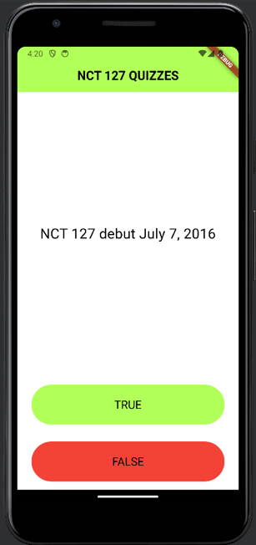 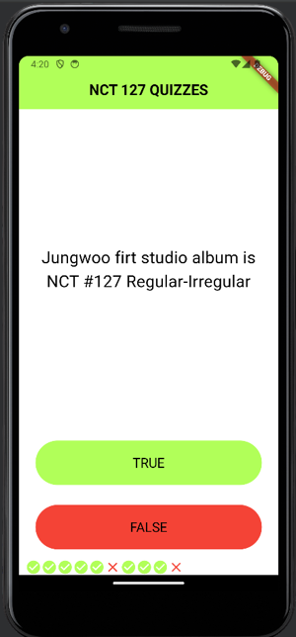 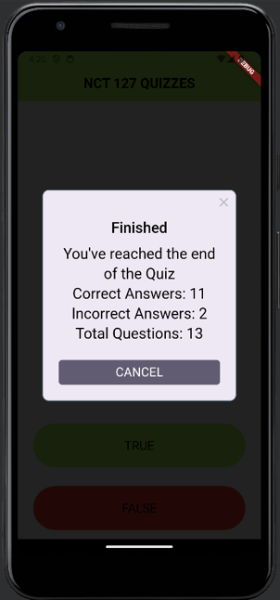

1. **Push Code to GitHub** <https://github.com/adelianurlinap/Prak_PBM.git>
2. Clone Repository yang telah dibuat :

|  |
| --- |
| git clone https://github.com/adelianurlinap/Prak_PBM.git |

1. Add dan commit

|  |
| --- |
| git add .  git commit -m "Tugas5" |

1. Push code

|  |
| --- |
| git push |

1. **Kesimpulan**

Pada tugas 5 ini, telah dilakukan praktek untuk membuat stateful app dan app dengan Alert.

1. **Referensi**

<https://github.com/adiwp/MobileProjects>